Pesticide Exposure Prevention:
F​ree Full Day Training
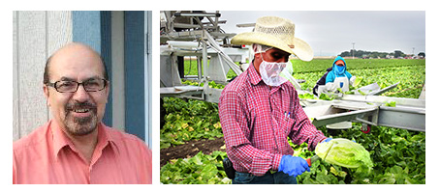
​​CHAMACOS, in partnership with the California Department of Education Migrant Education Office, is offering training​s for Migrant Education Program staff and parents. We will address pesticide exposure prevention and other health and safety challenges faced by farm-workers. ​​​This training partially aligns with State Service Delivery Strategies 9.0 and 9.2, providing health education information relevant to the prevention of chronic disease among migratory farm-workers.
Trainings will be in Spanish, and attendees will be expected to bring their own lunch. Participants will receive Worker Protection Standards Certification.
Attendees will gain the knowledge, skills and resources to train others on critical pesticide and farmworker​ ​health topics​, including ​how to minimize unintentional pesticide exposures, strategies to prevent take-home exposures of pesticides from the fields into homes, and reducing the likelihood that children will be exposed to harmful chemicals.
​About the Trainers: ​
CHAMACOS (Center for the Health Assessment of Mothers and Children of Salinas) is a community/university partnership between UC Berkeley School of Public Health and Clinica de Salud del Valle de Salinas studying pesticide and other environmental exposures and health impacts on pregnant women and their children living in the Salinas Valley, California. Trainings will be led by Mr. Jose Camacho a bilingual former migrant worker and past president of the Monterey County and Statewide Migrant Education Parent Council. Mr. Camacho has worked full time with CHAMACOS for 20 years conducting research on health in agricultural communities and leading community outreach and education on pesticide exposure prevention. This training series is funded by California Department of Education’s Migrant Education Program. ​Click here for more information about CHAMACOS and click here for links to farmworker education materials.
- Email Contacts:
  - CHAMACOS: Jose Camacho, chamacosoutreach@gmail.com or James Nolan, jnolan@berkeley.edu
  - Migrant Education Office: Lizette Rocha, lrocha@cde.ca.gov

